**Chapter IV**

This chapter presents the processed used by the researchers in the development of the Payroll System with RFID Technology for Computer Systems Instituteusing the Princeton Methodology. This chapter also included the discussion and analysis of the gathered data with the help of statistical tools.

1. **Initiation Stage**

This will be the primary phase of the development process in which the researcher will thoroughly examine the existing system at CSI. In this stage, the researcher will identify several issues and will provide suggestions for potential solutions. Since the CSI community will continue to grow, the need for a developed payroll management system will become increasingly important; therefore, CSI will be chosen as the primary beneficiary of the system.

In order to guarantee the accuracy of the data necessary for system development, the researchers will conduct a Key Informant (KI) interview with the President of CSI. Moreover, three sets of checklist survey questionnaires will be created to gather information from four respondent types: the President, Dean, Principal, and CSI teaching and non-teaching staff.

The researchers will initiate their process through the use of a Key Informant (KI) interview guide, which will consist of questions designed to interview the President, pinpoint issues, and gather knowledge about the current system of the Computer Systems Institute. The information gained from this interview will then be used to create a checklist survey questionnaire for the four key respondents: the President, Dean, Principal, and CSI teaching and non-teaching staff.

The first set of checklist survey questionnaires will be intended for the President. Although a Key Informant (KI) interview will already have been conducted, the researchers will proceed with the survey to validate the results of the interview, allowing them to better understand the current system and the problems encountered.

The President’s survey questionnaire will be divided into three (3) major parts. Part I will focus on the identification of the current method used in payroll production. Part II will focus on the identification of the problems encountered in payroll production. Part III will focus on the identification of possible solutions to the problems encountered in payroll production.

The second set of questionnaires will be for the CSI Teaching Staff and will also be divided into three (3) major parts. Part I will focus on the identification of the current method used for logging in and logging out of CSI Teaching Staff. Part II will focus on the identification of problems encountered in logging in and logging out of CSI Teaching Staff. Part III will focus on the identification of possible solutions to the problems encountered in logging in and logging out of CSI Teaching Staff.

The third set of questionnaires will be for the Dean and will be divided into three (3) main sections. Part I will focus on the identification of the current method used for monitoring the logging in and logging out of college Teaching Staff. Part II will focus on the identification of problems encountered in the monitoring of logging in and logging out of college Teaching Staff. Part III will focus on the identification of possible solutions to the problems encountered in the monitoring of logging in and logging out of college Teaching Staff.

The last set of questionnaires will be for the principal. The principal’s survey questionnaire will also be divided into three (3) major parts. Part I will focus on the identification of the current method used for monitoring the logging in and logging out of Senior High Teaching Staff. Part II will focus on the identification of problems encountered in the monitoring of logging in and logging out of Senior High Teaching Staff. Part III will focus on the identification of possible solutions to the problems encountered in the monitoring of logging in and logging out of Senior High Teaching Staff.

The collected data will then be organized, tabulated, and analyzed using the appropriate statistical tools. The following statistical tools will be used: Frequency will be used to determine the most dominant variables in the data, such as the current methods used, problems encountered, and possible solutions. Ranking will be used to determine the order of priority of the variables.

**1.A Computer Systems Institute current methods in payroll production, monitoring of logging in and out of college and senior high teaching staff, and logging in and logging out of teaching and non-teaching staff**

These are the current methods adopted by Computer Systems Institute in logging in and logging out, payroll production, and employee’s attendance monitoring. It includes the problems faced and the suggested solutions.

An interview guided by a multiple-response survey questionnaire was conducted, gathering data from thirty-eight (38) respondents, consisting of thirty-five (35) CSI teaching and non-teaching staff, including one (1) dean, one (1) principal, and one (1) president, who also serves as an administrator. Aside from the survey questionnaire, a key informant (KI) interview was also conducted for the administrator to acquire more detailed information concerning the stated processes or methods. The gathered data were then tabulated, presented and analyzed for purposes of this study.

**The Computer Systems Institute president current method used in payroll production**

In the gathered data, the president’s current method used in payroll production is **using Microsoft excel for computation of salary deduction and net pay.**

The president uses Microsoft Excel to compute salaries, deductions, and net pay. During the cutoff period, the faculty submits the manual monitoring forms to the principal. After collecting all the printed forms, the principal forwards them to the president, who calculates the hours worked by manually counting the hours recorded on the forms. The president then inputs this data, along with deductions for SSS, PAG-IBIG, PHILHEALTH, and any cash advances or loans, into Excel. Using pre-programmed formulas, the net pay is determined, and the gross pay is finalized. The payroll report is then printed and given to the cashier, who distributes it to the employees along with their pay slips. According to the president, this process is highly inconvenient for him, as he is solely responsible for payroll production.

The current manual payroll process has several negative effects. It is time-consuming for the president, who spends a lot of time calculating hours, entering data, and applying deductions, which can lead to delays in payroll and employee frustration. The process also increases the risk of errors, like incorrect pay, which can lower employee trust and require time-consuming corrections. As the organization grows, this system becomes less efficient, making it harder to keep track of payroll on time. The president, who is solely responsible for payroll, faces a heavy workload, which can lead to stress and less focus on other important tasks. Employees may also become unhappy with late or incorrect pay, which can harm morale. Additionally, the manual process makes it difficult to stay compliant with regulations and track changes, and it limits the ability to analyze payroll data for better decision-making.

To address these issues, implementing an automated payroll system with RFID technology would be a much more efficient solution. This system would eliminate the need for manual attendance tracking, streamlining the entire payroll process. It would offer greater convenience in computing payroll, storing and retrieving data, and generating payroll reports and pay slips. By automating these tasks, the organization could reduce errors, save time, and improve overall efficiency, allowing management to focus on more strategic activities.

**The Computer Systems Institute dean current method used for monitoring the logging in and out of college teaching staff**

The current method used by the dean in monitoring of logging in and out of college teaching staff are: **Inquiring with the school guard about which members of the college teaching staff have arrived at work; Room tour or check on the college teaching staff to see if they entered the class or not.**

The dean identified two (2) methods in monitoring of logging in and out of college teaching staff. The first method used is inquiring with the school guard about which members of the college teaching staff have arrived at work. In the extension, the dean cannot monitor the college teaching staff because the extension is somewhat distant and involves a lot of hustles. Therefore, to track the teaching staff, he asks the guard whether they have reported to work or not.

Another method used is room tour to check on the college teaching staff to see if they entered the class or not. The dean conducts room-to-room checks in the main building to verify whether faculty members are present for work.

The dean's current methods for monitoring faculty attendance—asking the school guard about arrivals and conducting room tours—are inefficient and time-consuming. Relying on the guard can lead to inaccuracies, and room checks only provide a limited view of staff attendance. These methods also delay information and make it harder to address attendance issues quickly. The dean spends too much time on attendance tracking instead of focusing on other important tasks, and the lack of real-time data makes it difficult to ensure accountability.

Additionally, these methods may cause frustration among faculty members. To improve the process, the administrator could implement an automated attendance system, like RFID tracking, which would provide real-time data, reduce administrative work, and help ensure more accurate attendance monitoring.

**The Computer Systems Institute principal current method used for monitoring the logging in and out of senior high teaching staff**

The current method used by the dean in monitoring of logging in and out of senior high teaching staff is **room tour or check on the college teaching staff to see if they entered the class or not.**

The principal's current method for monitoring the logging in and out of senior high teaching staff involves conducting manual room tours to check if teachers have entered their classrooms. This process requires the principal to visit each room in the main building to ensure that faculty members are present. However, this method is time-consuming, inefficient, and provides only a limited view of attendance, making it difficult to track teachers' exact arrival and departure times. Additionally, it delays the ability to address attendance issues and takes time away from more important administrative tasks. To improve efficiency and accuracy, the administrator could implement an automated attendance system, such as RFID tracking, which would allow for real-time monitoring, reduce administrative workload, and ensure more reliable tracking of staff attendance.

**Table V**

**Teaching and Non-Teaching Staff’s Current Method in Logging in and Logging Out**

|  |  |  |
| --- | --- | --- |
| **Methods** | **F** | **Rank** |
| Manually logging in and logging out printed attendance monitoring form. | 26 | 1 |
| Printed DTR | 3 | 2 |

N = 29

Table V presents the Computer Systems Institute faculty current method adopted in logging in and logging out. As shown in the table, the methods are listed in order of most to least preferred: first, twenty-six (26) faculty members claimed to manually log in and log out of the of the printed attendance monitoring form.; second, three (3) faculty member stated of using the printed DTR.

In analysis, the current method used for logging in and out by teaching and non-teaching staff is manual. They receive a printed monitoring form to record their actual time in and out, which must be signed by the students. And some teaching staff use MS Excel, a digital version of the monitoring form, and a logbook or record book. The printed monitoring form will be submitted to the payroll in-charge on the 14th and 29th of each month for salary computation.

**1.B Problems encountered at Computer Systems Institute current methods in payroll production, monitoring of logging in and out of college and senior high teaching staff, and logging in and logging out of teaching and non-teaching staff**

**Problems encountered by the president in the current method used in payroll production**

The president identified the problems with the current payroll production method: **not accurate computation of teaching staff hours rendered, and manual production of payroll is time-consuming.**

The president highlighted a few problems with the current payroll process. First, the payroll production often has errors. Second, non-teaching staff hours are not accurately recorded, which results in mistakes in their pay. Lastly, manually creating the payroll requires a lot of time.

The payroll computations are not accurate because the current manual process is prone to errors. Tracking hours worked manually, can lead to mistakes, such as miscalculating hours. Inaccurate time logs and the reliance on paper forms make it harder to catch these errors. Additionally, using Excel for manual entries increases the chances of input mistakes or incorrect application of formulas. These issues result in incorrect pay and highlight the need for an automated system to ensure accuracy and consistency in payroll processing.

This shows that an automated payroll system with RFID is necessary to address these problems. Such a system can ensure precise payroll production, reduce errors, and correctly track non-teaching staff hours, resulting in proper payment of their time worked.

**Problems encountered by the dean in the current method used for monitoring the logging in and out of college teaching staff**

The dean pointed out issues with the current method for monitoring the logging in and out of college teaching staff: **manual checking of logging in and out of college teaching staff is time-consuming and tedious or tiresome.**

     The dean stated various issues with the existing system for tracking when college teaching staff log in and out. The issues with the current method of monitoring staff attendance come from relying on manual checks, which are both time-consuming and tiring. The dean has to physically visit each classroom to see if staff are present, which takes up a lot of time, especially in a large school. This process is also repetitive and exhausting, as the dean has to keep checking classrooms regularly. Because it’s a manual system, there’s also a higher chance of missing staff members or making mistakes, like not noticing if someone arrives late or leaves early. These problems happen because manual methods are slower, more prone to errors, and require a lot of effort.

This illustrates the need for an automated system for monitoring college teaching staff time-in and time-out, which will save time and improve accuracy over manual methods, making the entire process more efficient and reliable.

**Problems encountered by the principal in the current method used for monitoring the logging in and out of senior high teaching staff**

The principal selected that the current method of monitoring logging in and out of senior high teaching staff is **manually checking of logging in and out of senior high teaching staff is time-consuming.**

The principal mentioned that the current method of monitoring where senior high school teaching staff time in and time out is challenging because it is based on manual time checks. Manually checking the time-in and time-out of senior high teaching staff is time-consuming because it requires the principal to physically go from room to room to track each teacher's arrival and departure. This takes a lot of time, especially if there are many teachers or buildings to monitor. The process also relies on human memory and attention, which can lead to missed times or errors. Overall, it's a slow and inefficient method that demands a lot of time and effort. This emphasizes the necessity for an automated system, which can record these times quickly and correctly without requiring manual input. This not only saves time but also lowers the workload.

**Table VI**

**Problems encountered by the teaching and non-teaching staff in the current method used logging in and logging out**

|  |  |  |
| --- | --- | --- |
| **Methods** | **F** | **Rank** |
| Sometimes I forgot to have my student sign the manual attendance monitoring form, especially when I’m too engaged in class. | 15 | 1 |
| I occasionally forget to bring my attendance monitoring form. | 9 | 2 |
| Using the monitoring form is time-consuming. | 8 | 3 |
| The attendance monitoring form being used is not accurate for computation of rendered hours. | 5 | 4 |

N = 25

Table VI shows the problems encountered by the teaching and non-teaching staff using the current method adopted for logging in and out. The following are the identified issues faced by the Computer System Institute’s teaching and non-teaching staff. First, **they forgot to have the students sign the manual attendance monitoring form, especially when they are too engaged in class,** as reported by fifteen (15) individuals. Second, **sometimes they forgot to bring their attendance monitoring form,** noted by nine (9) individuals. Third, **using the monitoring form is time-consuming**, which was identified by eight 8) individuals. Lastly, **the attendance monitoring form being used is not accurate for computation of rendered hours**, as indicated by five (5) individuals. These particular problems encountered by the teaching and non-teaching staff are brought by the current method adopted by the Computer Systems Institute.

**Table VII**

**Recommended possible solutions to address the problems encountered**

|  |  |  |  |  |  |
| --- | --- | --- | --- | --- | --- |
| **Methods** | **President** | **Dean** | **Faculty** | **Total** | **Rank** |
|  | **F** | **F** | **F** | **F** |  |
| A system or storage and retrieval of logging in and logging out of teaching and non-teaching staff | 0 | 1 | 14 | 15 | 1 |
| A system for monitoring of logging in and logging out of teaching and non-teaching staff | 1 | 1 | 12 | 14 | 2 |
| A system for payroll production | 1 | 1 | 11 | 13 | 3 |
| An automated system for monitoring of teaching personnel through SMS who logged in and logged out | 1 | 1 | 10 | 12 | 4 |

N = 28

**Preliminary Planning.** Based on the analyzed data and feedback from respondents, the researcher proposed a Payroll System with RFID to assist the payroll personnel in streamlining payroll processing, addressing the issues faced by staff, and suggesting potential solutions. This system improves school payroll management by automating processes, ensuring accurate and timely payments, ease the workload, and reducing errors. RFID tracks staff attendance in real-time, allowing for easier monitoring and automated notifications, while increasing efficiency, data security, and cost savings. Additionally, the SMS support feature will notify the Dean and the Principal once the teaching staff tap their RFID card.

1. **Analysis Stage**

The researcher examined and evaluated the current payroll system utilized by the Computer Systems Institute, identifying the essential requirements for the new system.

* 1. **Business Analysis.** Figure 1 presents the current system on payroll production.

1. The teaching staff manually writes their log in/out times using a printed monitoring form, which is signed by students.
2. Every cutoff, the faculty submits the manual monitoring form to the principal. After collecting all the printed forms, the principal forwards them to the president.
3. The president calculates the hours worked using a pre-programmed formula. Once the net pay is determined, deductions for SSS, PAG-IBIG, PHILHEALTH, and any cash advances or loans are made, and the gross pay is finalized.
4. The payroll report is printed and given to the cashier, who then distributes it to the employees along with their pay slips.

**2.2 System Analysis.** Based on the information gathered, a payroll system with RFID is the practical solution, as it provides a database that stores all records collected, and allows for easy storage and retrieval of payroll reports and payroll production.

**Scope.** This study focuses on the development of the payroll system in terms of automated tallying of schedules, monitoring of attendance using RFID, accurate computation of payroll, production of payroll, SMS attendance notification for Dean and Principal.

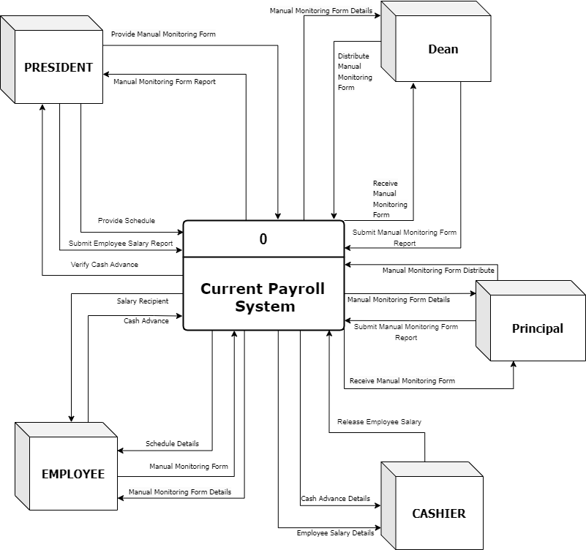

*Figure 1. The current Payroll System of Computer Systems Institute*

**Expected Output.** The following are the expected output of the proposed system: An automated payroll for accurate computation of payroll, contributions and other deductions; monitoring of attendance; A database for saving payroll reports; production of payroll; and An SMS server that sends a confirmation text message to the dean and principal when the teaching staff logs in and out. These outputs are expected to be implemented in the system.

The developed systems have two modules (2) for different users.

**Login Module** for use of all the user to access the system for specific purposes.

**Admin Module** for use of the president for processing the payroll.

**RFID Module** for use of the staff to time in and time out using RFID.

**Users or stakeholder’s transactions.** The following are the stakeholders of the proposed system.

**President** - The president is the primary beneficiary of the system. Payroll processing falls under the responsibility of the president.

**Dean** – When a faculty member (college teaching staff) time in and time out, the system sends out SMS notifications to the dean to maintain attendance accuracy.

**Principal** - The system notifies the principal via SMS when a faculty member (senior high teaching staff) times in and times out in order to ensure attendance accuracy.

**Faculty** - Faculty members will benefit from this system. The proposed system will record their attendance. They can use their RFID to time in and time out. The system ensures that employees are paid accurately and on schedule, avoiding compensation problems.

**System Objectives.** This project aims to develop a Payroll System with RFID for the Computer Systems Institute and has the following objectives.

1. Provide Computer System Institute with a database server to be used for storing and retrieving payroll reports.
2. Provide an RFID device to facilitate easy logging in and out for teaching and non-teaching staff, along with a database for storing employees' daily attendance records.
3. Automated salary computation for the convenient in payroll production.

**Advantages.** The systems proposed the following advantages:

1. Teachers and non-teaching staff can easily tap their RFID card for attendance, making it simpler to log in and out. There's no need for printed monitoring form or attendance reports because their log in and out are automatically recorded in the database, reducing the chances of errors in hour calculations.
2. Payroll processing becomes more efficient, removing the need for repeated data entry.
3. Monthly contributions and other deductions, such as SSS, Pag-IBIG, PhilHealth, loans, and cash advances, can be updated at any time.
4. Monitoring employees is much easier with SMS notifications when they log in and out.

**Disadvantage.** The proposed system has also disadvantaged:

1. The purchase of a server computer will add costs to the institution.
2. Since the proposed system will utilize SMS, there may be times when the SIM signal is weak.
3. The RFID device and system cannot be used during power interruptions.

**Resources required.** Both human and technical resources are required for the development of the proposed system.

**Human Resources**

1. System Analyst – The system analyst is responsible for analyzing business needs and evaluating the proposed system in relation to the existing manual processes at the Computer Systems Institute.
2. Programmer – The programmer is responsible for the actual development of the system, including writing the source code, debugging, and implementing the system.

**Technical Resources**

For the development of the system

1. Personal Computer

- Intel Core i5--6200U @ 2.30Ghz

- 8GB RAM DDR3

- 256GB SSD

- 1 4" Display (1366x768)

- USB 2.0 Keyboard

- USB 2.0 Mouse

1. Hardware

* RFID Reader
* RFID Card
* GSM Module

1. Software

* WINDOWS 10 OS
* MySQL Database Server v8.0
* MySQL Workbench 8.0.38
* Visual Basic C# version 2019

**Implementation of the system**

- AMD Ryzen 5 5600G @3.9Ghz

- 8GB RAM DDR4

- 256GB SSD

- MSI 21.5” Monitor

- USB 2.0 Keyboard

- USB 2.0 Mouse

* RFID Reader
* RFID Card
* GSM Module

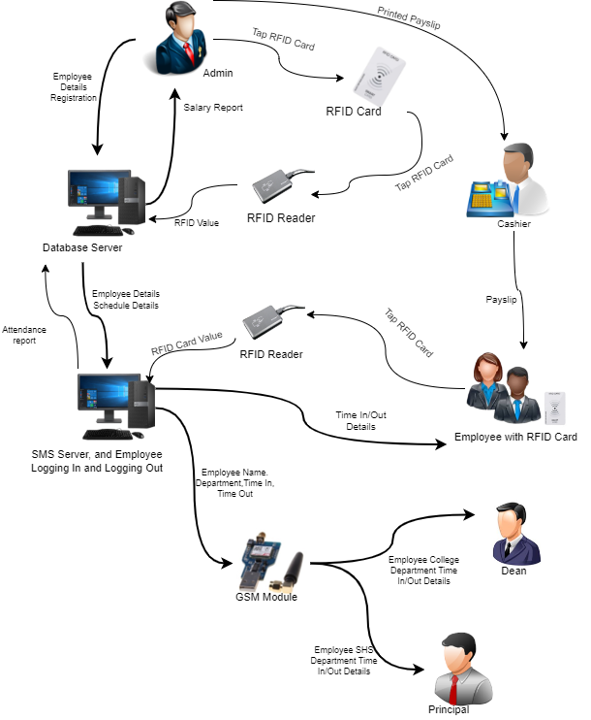**Transaction Sequence Model.** Figure 2 shows proposed works.

*Figure 2. Transaction Sequence Model shows how the system works.*

This model describes an RFID-based system for managing employee attendance and payroll. The process begins when an administrator enters employee information, such as ID, department, and schedule, into a Database Server, which securely stores these details. Each employee is assigned an RFID card, which they use to clock in and out by tapping it on an RFID Reader. The reader records their time in and out and transmits this data to the Database Server for processing. The server then compiles attendance records and employee schedules, generating attendance reports and calculating payroll. A GSM module sends attendance notifications to the Dean and Principal, providing updates on employee attendance times. For payroll, the administrator creates a salary report based on attendance records, which is printed on a payslip for the employees.

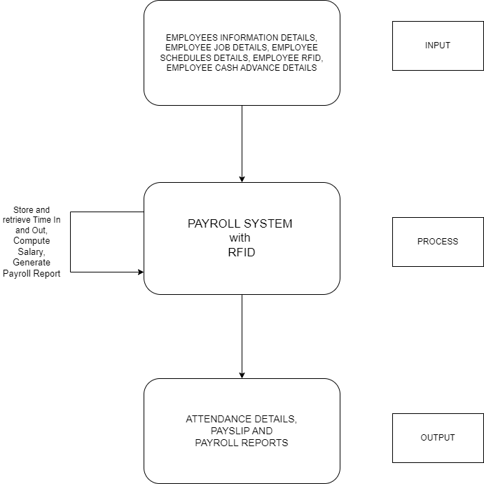*Figure 3. The Conceptual Design of the Proposed System*

The computed salaries will be saved to the database and generate summary reports and individual pay-slip. The generated payroll reports and pay-slip are can be printed.

**Conceptual Design.** Figure 3 presents the system's conceptual design, illustrating how inputs are processed to generate the desired output. It highlights the input, process, and output of the proposed system.

**Outputs.** The output of the proposed system for the particular stakeholders is as follows:

The system will produce daily time records, monthly salary cut-off reports, and payroll summaries.

The outputs stakeholders are as follows:

**Administrator/President**: Automated salary calculations, including total gross pay, contributions, cash advances, other deductions, late arrivals, absences, and net pay.

**Inputs.** The following are the inputs required to achieve the desired output of the proposed system.

**Login Module**

* The Administrator/President will need to log in using their password to gain access to the system.

**Admin Module.**

* Employees profile such as employee ID, RFID, First Name, Middle Name, Last Name, Picture, Department, Position, Basic Salary, Per Hour Teaching Load Salary, Date Started.
* Schedule details such as employee name, schedule day, time in and time out, schedule period, year, schedule type, schedule semester.
* Payslip details such as employee name, date, cutoff, base salary, teaching load salary, contributions, cash advance, other deductions, gross income, and net income.
* Payroll details such as total employee that has salary, cutoff, year, month, total deductions, total gross income, total net income.

**RFID Module**

* Attendance details such as date, time in and time out, period, status.

**Process.** The following are the data processing of the proposed system.

**Login Module**

* The system will check if the inputted username and password are correct to log in.

**Admin Module.**

* The system can retrieve all the employee attendance from the database server.
* The system can compute all the employee rendered hours, cash advance, contributions, other deduction, net income, and gross income.
* The system can generate payslip and payroll reports.

**RFID Module**

* The system will display employee time-in and time-out details each time an RFID tag is tapped on the reader. Also, a SMS notification of employee attendance time in and out will be sent to Dean and Principal.

**Performance.** This pertains to the system’s reliability and ability to handle and process data effectively.

* The system is capable of handling and storing larger amounts of data.

**Controls.** The proposed system includes the following features.

1. **Login Module.**
   * System Login
   * Verify Login
2. **Admin Module.**

* Add/Update Employee Info
* Add/Update Employee RFID
* Add/Update Employee Job
* Add/Update Schedule
* Add/Update Cash Advance
* Retrieve Daily Time Record
* View Attendance
* View Payslip
* Compute Salaries

1. **RFID Module.**

* Store Daily Time Record
* Send SMS Notification
* Display DTR Details

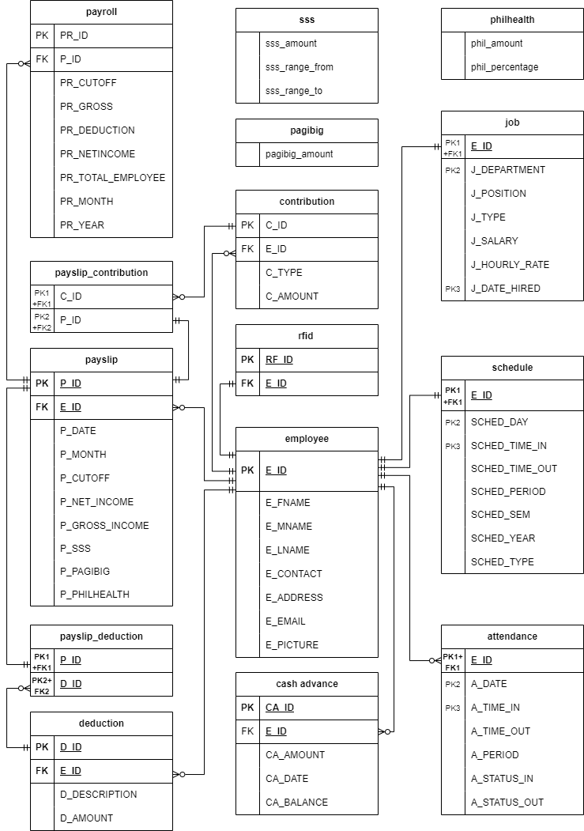

*Figure 4. The Entity Relationship Diagram of the Proposed System*

1. **The Design Stage**

This stage involves creating both the logical and physical designs. An Entity Relationship Diagram (ERD) is used to represent the relationships between entities and the system’s workflow.

* 1. **The Logical Flow.** The diagram outlined in Figure 4 demonstrates the interrelationships between the entities and the data flow of the proposed system.

This Entity-Relationship Diagram (ERD) outlines a system for managing payroll and attendance. At its core is the Employee entity, which holds personal details like name, contact information, and address. Each employee has related Job information, including department, position, salary, and hire date, which defines their role within the organization. The Schedule and Attendance entities work together to track each employee's working hours. Schedule sets expected work times, while Attendance logs actual hours worked, allowing for comparison and tracking of attendance status. Payroll management is handled by the Payroll and Payslip entities. Payroll stores data on each payroll period, including gross income, deductions, and net income for all employees. The Payslip entity provides a breakdown for each individual, showing specific contributions like SSS, Pag-IBIG, and PhilHealth. The system also includes entities for managing government contributions and other deductions. SSS, Pag-IBIG, and PhilHealth entities hold the amounts and ranges for these contributions, which are used in payroll calculations. Additional deductions are tracked in the Deduction entity, which stores descriptions and amounts. Other features include Cash Advance, which tracks loans or advances given to employees, and RFID, which is likely used for attendance tracking via RFID technology.

**The Context Flow Diagram of the Proposed System.** Figure 5 provides an overview of the context flow of the proposed Payroll System with RFID. The main entities of the system are the President, Dean, Principal, and Employee. In this system, employees log their attendance by scanning their RFID tags, which records their time in and out in the system. The President, as an administrator, can log into the system to input details such as employee schedule, contribution information, employee profile, and cash advance data into the system’s database. The system processes this information to generate outputs such as payroll reports. These payroll reports can then be viewed and printed by the President for record-keeping and verification.

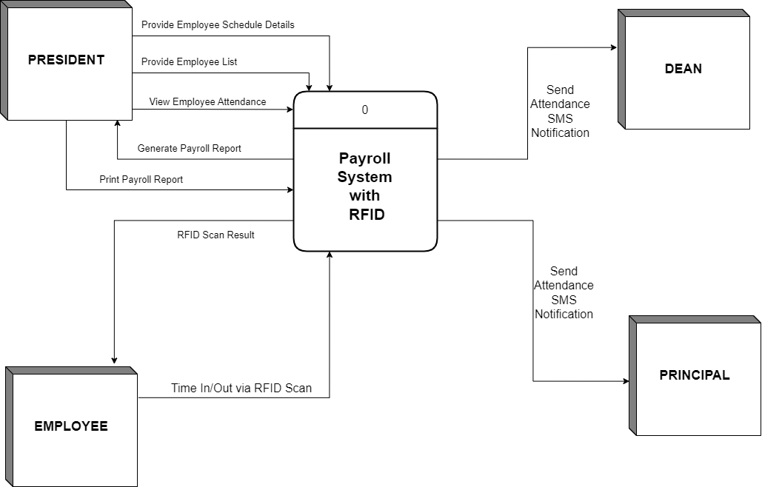

*Figure 5. The Context Flow Diagram of the Proposed System*

Additionally, the system is equipped with an SMS notification feature, which sends automated attendance updates to the Dean and Principal, keeping them informed of employee attendance status without manual tracking. After each payroll period, the payroll report is generated and stored in the system’s database for viewing by the President.

**The Login Module.** Figure 6 shows data flow diagram of the admin login module of the proposed system.

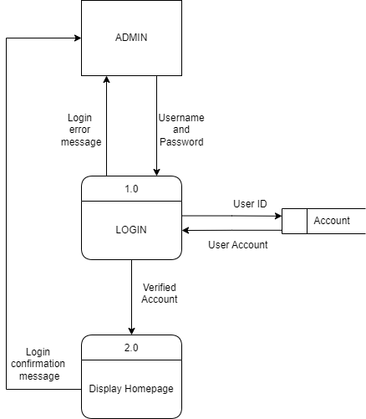

*Figure 6. The Data Flow Diagram of the Login Module*

**Process 1.0** The administrator enters username and password, the system checks the user account for a matching username and password. If no match is found, a login error message is displayed; otherwise, the system moves to the next step.

**Process 2.0** Upon receiving a verified account from the Login process, the system progresses to the "Display Homepage" module. A Login confirmation message is generated for the administrator, and the homepage or main dashboard is displayed.

From the Login Module

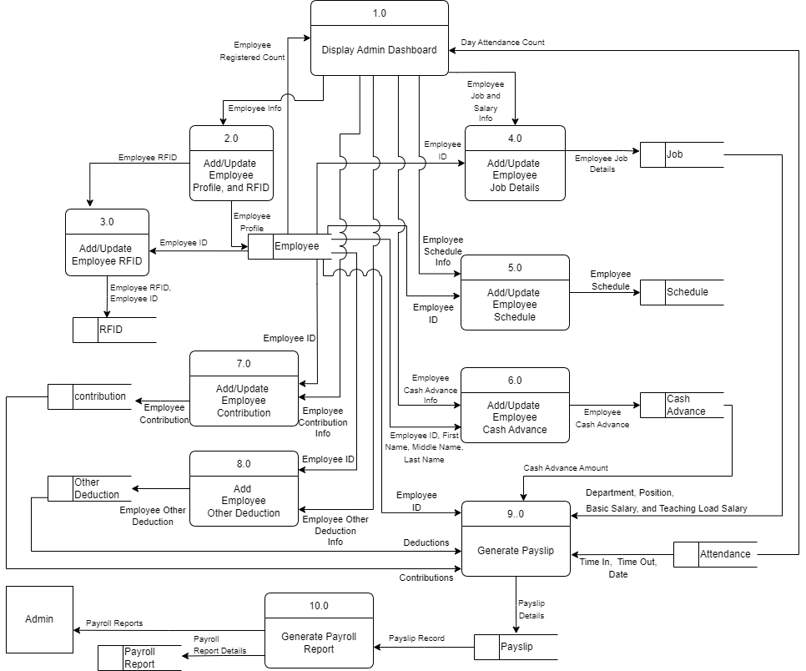

*Figure 7. The Data Flow Diagram of the Admin Module*

**The Admin Module.** Figure 7 show the data flow diagram of the Admin Module of the proposed system.

**Process 1.0** From the supplied user ID of the Login Module, this process displays the homepage or main dashboard details.

**Process 2.0** This process adds/updates the employee info such as First Name, Middle Name, Last Name, Contact, Email, Address, Photo.

**Process 3.0** This process adds/updates the employee RFID from the employee details supplied by Process 1.0.

**Process 4.0** This process adds/updates the employee job details such as position, department, date hired, job type, and salary.

**Process 5.0** This process adds/updates employee schedule such as day, time in and time out, period, type, year, and semester.

**Process 6.0** This process adds/updates employee cash advance such as cash advance amount, date, and balance.

**Process 7.0** This process adds/updates if employee has contribution such as SSS, PagIbig, and PhilHealth.

**Process 8.0** This process adds if employee has other deduction like loans.

**Process 9.0** This process generate payslip that has a computation of employee salary, cash advance, contribution, other deduction.

**Process 10.0** This Process generate payroll reports that has a total employee, total gross income, total net worth, and total deduction details supplied by the Process 9.0.

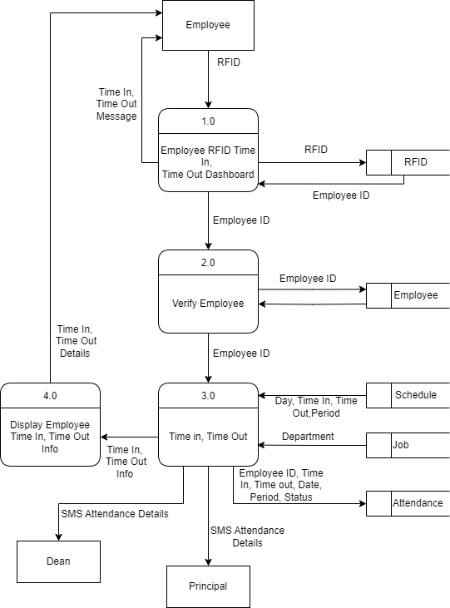

*Figure 8. The Data Flow Diagram of the Admin Module*

**The RFID Module.** Figure 8 show the data flow diagram of the RFID Module of the proposed system.

**Process 1.0** The system verifies the employee using the RFID, if not found time in or time out error message will be generated, else proceed to next process.

**Process 2.0** The system verifies the RFID holder from employee data table using the employee id retrieve from Process 1.0.

**Process 3.0** The system verifies the time in, or time out from schedule data table, then generate send SMS attendance notification to Dean or Principal.

**Process 4.0** This process displays the time in or time out details.

**System Layout.** Figure 9 shows the system layout for the proposed Payroll System with RFID. In this system, the administrator uses a PC to access attendance records and manage payroll tasks.

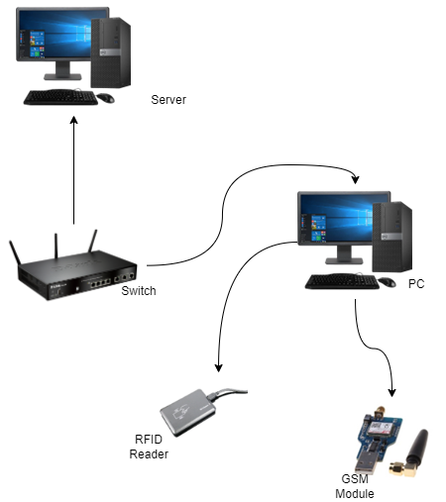

*Figure 9. The Payroll System With RFID Layout*

A Local Area Network (LAN) connects the administrator's computer with the employee time-in and time-out dashboard, allowing shared access to the database. This LAN connection is enabled through a switch router. An RFID reader scans employee RFID tags to record daily time-ins and time-outs. Additionally, a GSM module is included to send SMS notifications to the Dean or Principal when an employee time in or out.

**The Development Stage**

This phase will be the development stage of the system, where everything will be implemented, including coding and interface design. During this phase, system users will receive training, and the system will undergo testing and evaluation to ensure its functionality.

**Constructions.** The researcher used a Visual Studio C# Language, MySQL Database Server v8.0, MySQL Workbench 8.0.38, and WINDOWS 10 OS in developing the proposed system.

**User Controls.**

The following are the significant user controls of the proposed system.

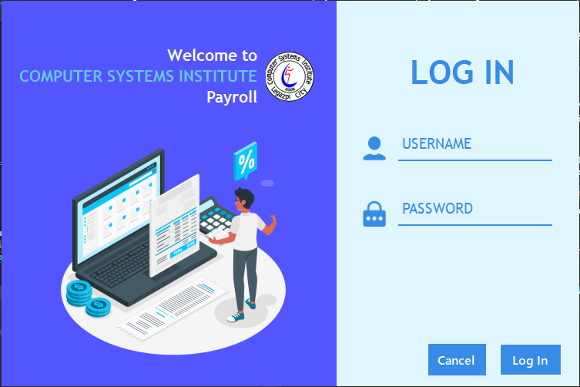

*Figure 10. The Login Module Screen*

*The first screen of the proposed system is the login page (Figure 10). On this page, the user will see the CSI logo and name. Next to it is a textbox where the admin can enter their username and password to log into the system. There is also a "Login" button to move to the next page and a "Cancel" button to exit the program.*

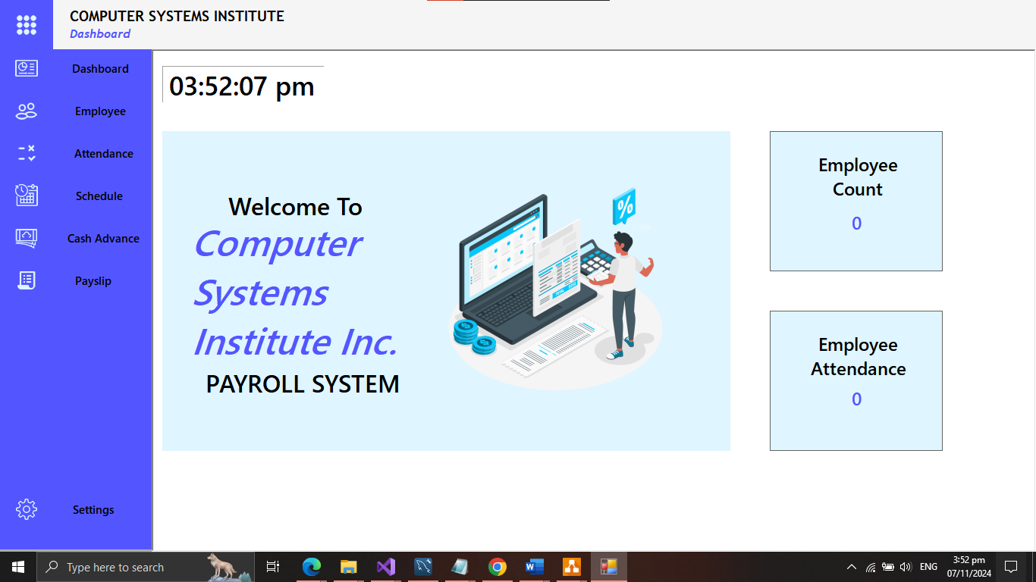

*Figure 11. The Dashboard Module Screen*

Figure 11 shows the dashboard, or homepage, of the system. After the admin logs in, they will be redirected to the homepage. On this page, the admin can view the current time, the total number of employees, and the attendance count. In the top-right corner of the page, there is a button that, when clicked, will close the side navigation bar. If the bar is closed, clicking the button will open it. The side navigation bar contains several buttons, including those for the dashboard, employee management, attendance, schedule, cash advances, and payslips.

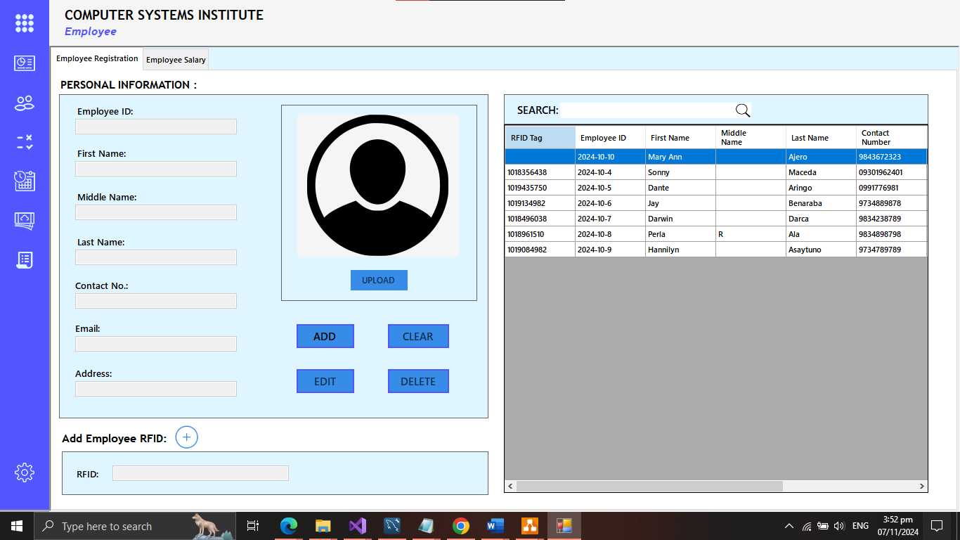

*Figure 12. The Admin Employee Module Screen*

The employee page is the user can view, add, update, and delete the personal info of each employee (Figure 12).

**ADD Button.** The add button will unlock the textbox. After unlocking the user can input the employee info and upload employee photo.

**Edit Button.** The edit button will also unlock the textbox if the user select an employee on the data gridview. After clicking the button text will change to update, indicating that its for update if a user make changes on the employee info.

**Clear Button.** The clear button will clear all the text inside the textbox, including the image. Then after it’ll reset the buttons.

**Delete Button**. The delete button will delete the selected employee in the data grid view.

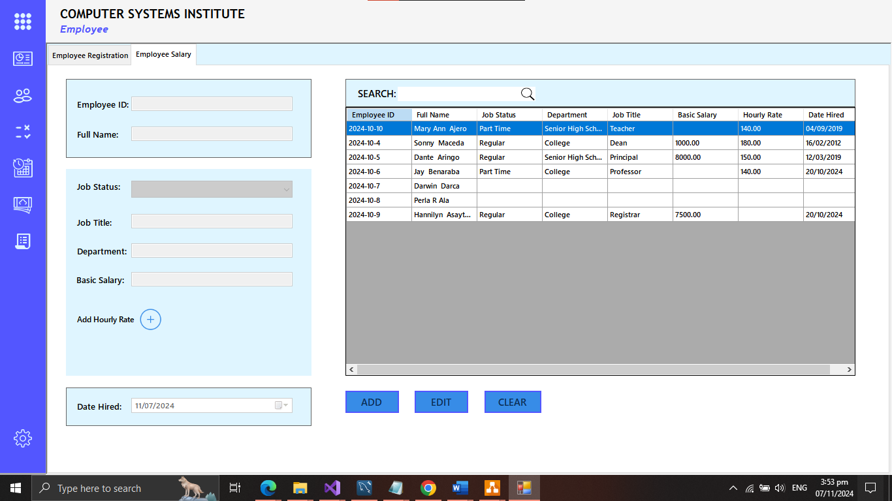

*Figure 13. The Admin Employee Job Module Screen*

Figure 13 shows where the user can add, edit the employee

Job status, department, salary, and title.

**ADD Button.** The add button will unlock the textbox. After unlocking the user can input the employee info and upload employee photo.

**Edit Button.** The edit button will also unlock the textbox if the user select an employee on the data gridview. After clicking the button text will change to update, indicating that its for update if a user make changes on the employee info.

**Clear Button.** The clear button will clear all the text inside the textbox, including the image. Then after it’ll reset the buttons.

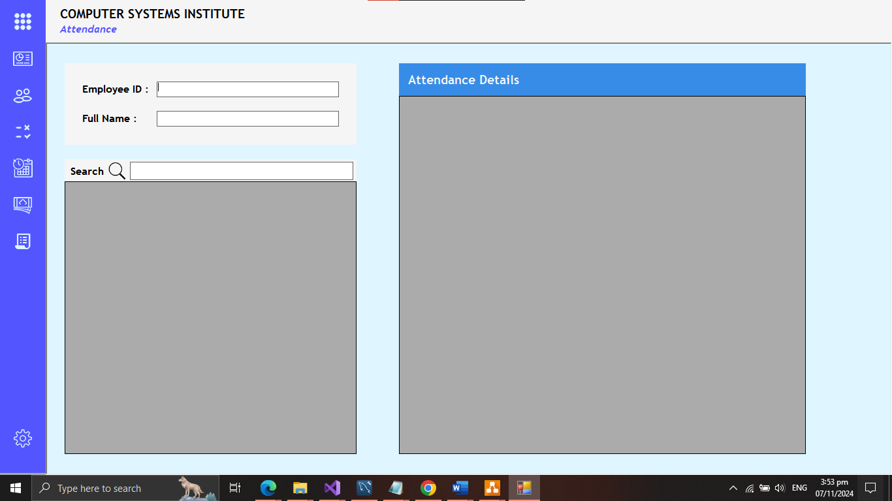

*Figure 14. The Admin Employee Attendance Module Screen*

This page shows the user about the daily time record of an employee of the day (Figure 14). The user can search the employee name to display the daily time record of that employee in the data grid view.

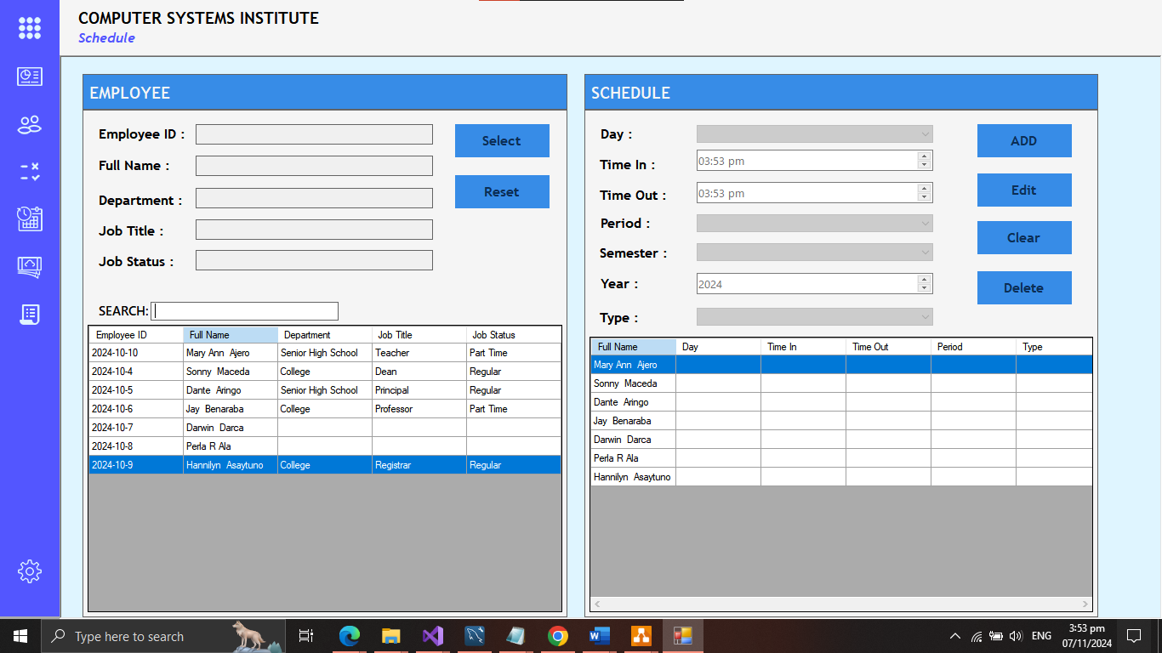

*Figure 15. The Admin Employee Schedule Module Screen*

*Schedule section is where the user can view, add, update, and delete the employee schedule (Figure 15).*

**Select Button.** The user will select an employee on the data grid view, then when button select are click it’ll enable the schedule panel.

**Reset Button.** Button to clear all the field and reset all the changes made on the textbox.

**Add Button.** Button to add employee schedule and store the record on database.

**Edit Button.** The edit button will also unlock the textbox if the user select an employee on the data gridview. After clicking the button text will change to update, indicating that its for update if a user make changes on the employee info.

**Clear Button.** The clear button will clear all the text inside the textbox, including the image. Then after it’ll reset the buttons.

**Delete Button**. The delete button will delete the selected employee schedule in the data grid view and database.

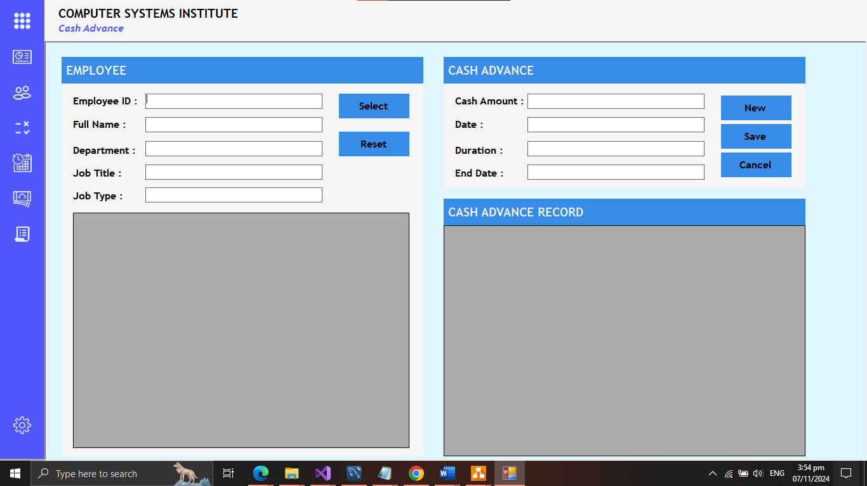

*Figure 16. The Admin Employee Cash Advance Module Screen*

*Cash advance section is where the user can view, add, update, and delete the employee cash advance (Figure 16).*

**Select Button.** The user will select an employee on the data grid view, then when button select are click it’ll enable the cash advance panel.

**Reset Button.** Button to clear all the field and reset all the changes made on the textbox.

**Add Button.** Button to add employee cash advance and store the record on database.

**Edit Button.** The edit button will also unlock the textbox if the user select an employee on the data grid view. After clicking the button text will change to update, indicating that its for update if a user make changes on the employee info.

**Clear Button.** The clear button will clear all the text inside the textbox, including the image. Then after it’ll reset the buttons.

**Delete Button**. The delete button will delete the selected employee cash advance in the data grid view and database.

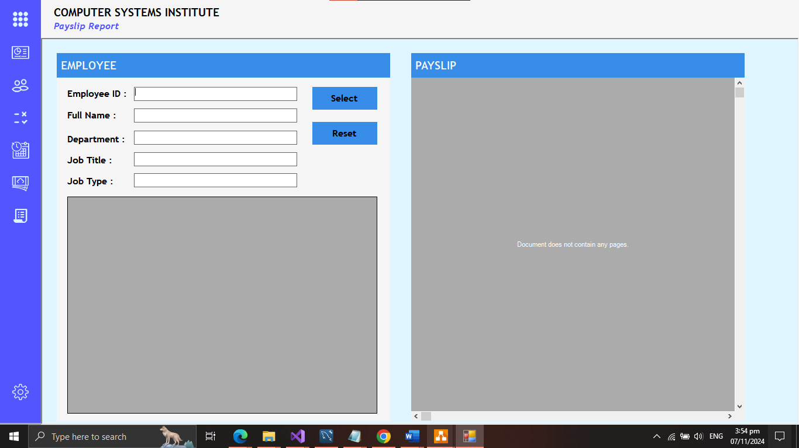

*Figure 17. The Admin Employee Cash Advance Module Screen*

*Payslip section is where the user can view and generate the employee payslip (Figure 17).*

**Select Button.** The user will select an employee on the data grid view.

**Reset Button.** Button to clear all the field and reset all the changes made on the textbox.

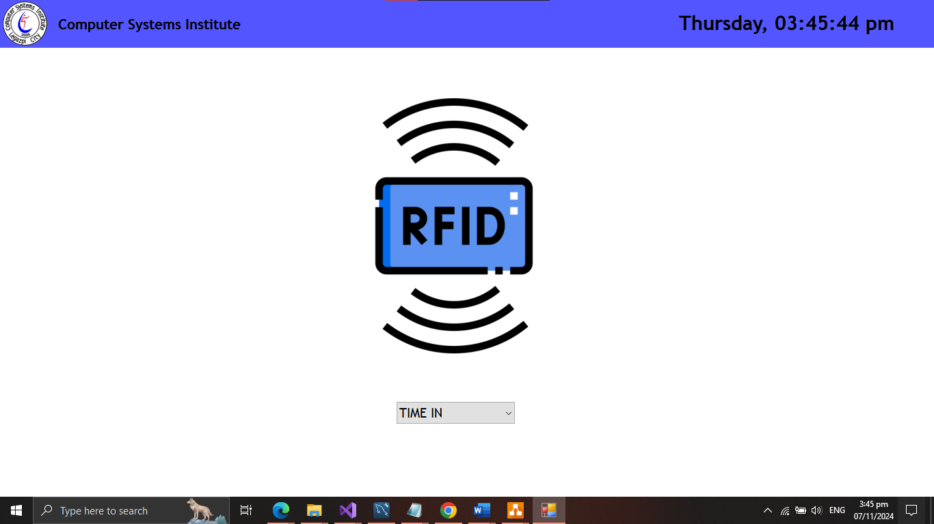

*Figure 18. The RFID Module Screen*

This page shows the RFID logo and below are drop down list to choose between time in and time out (Figure 18). When an employee are done choosing between the two, they have to tap or swipe the RFID on RFID reader to store the time in or time out on the database server.

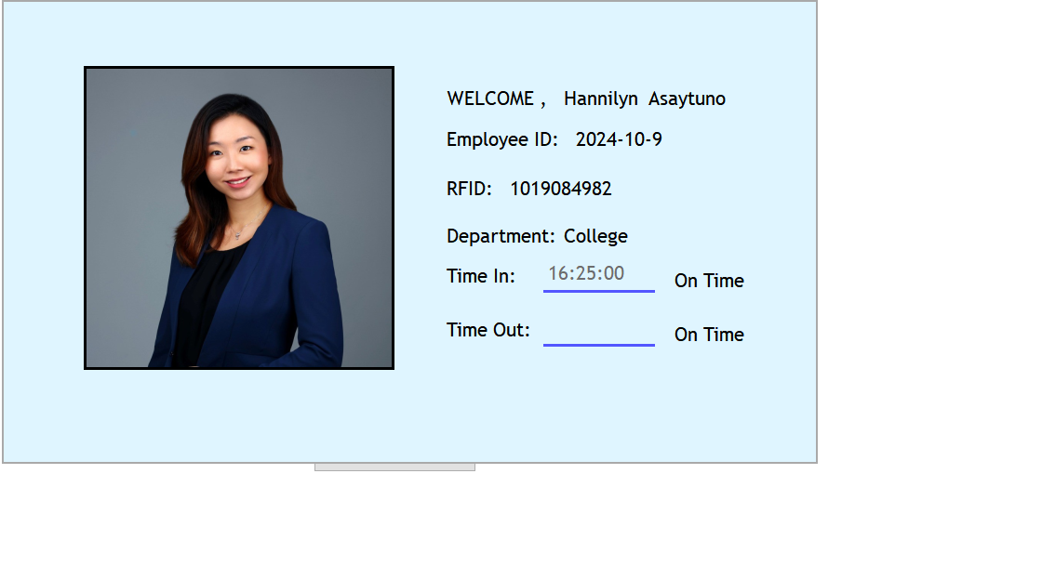

*Figure 19. The RFID Time IN/OUT Module Screen*

Figure 19 shows the employee full name, employee id, employee photo, RFID, department, time in and out, and also the status, after a successful time in or time out.